https://msds.open.ac.uk/signon/SAMS001_CDC.aspx?nsh=2&INF=OFF001&
Password: Master123?
Username is Sa24684

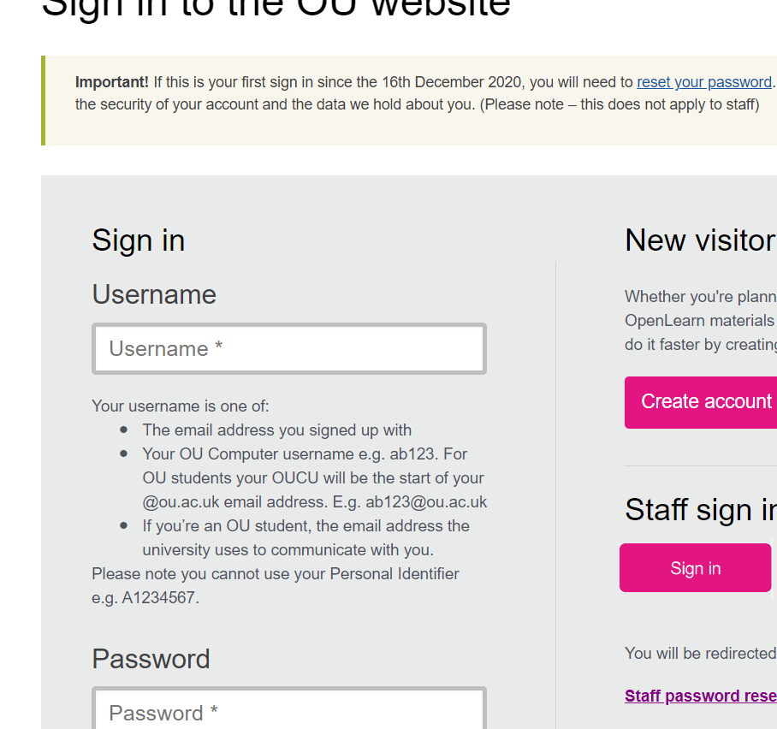

Once logged in click on Student Home
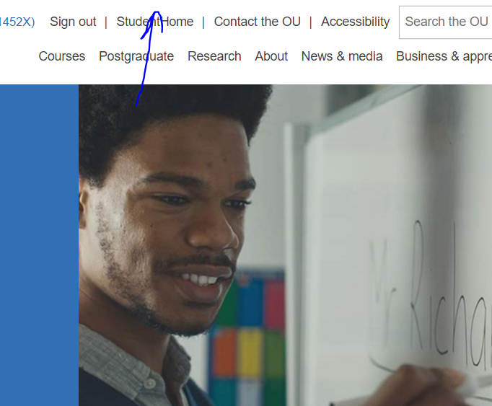

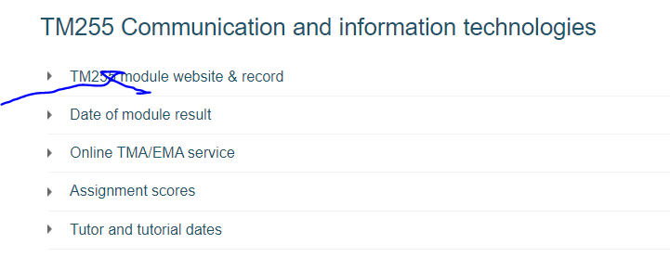
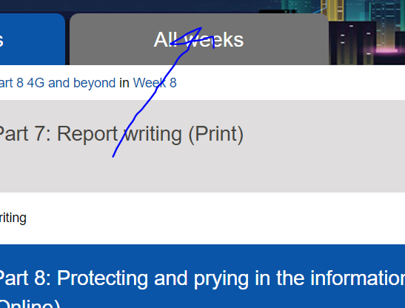

Go down to Week 10 and click on word press server
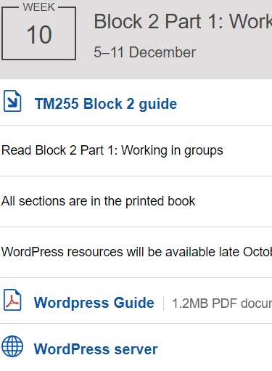
- Click on Log in or go to Site Admin
The use these logins
sa24684@ou.ac.uk
Master12345?!

